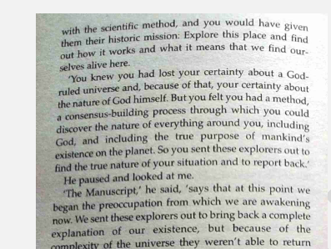

With the scientific method, and you would have given them their historic mission: Explore this place and find out how it work and what it means that we find our-selves alive here.

‘You knew you had lost your certainty about a God-ruled universe and, because of that, your certainty about the nature of God himself. But you felt you had a method, a consensus-building process through which you could discover the nature of everything around you, including God, and including the true Purpose of mankind’s existence on the planet. So you sent these explorers out to find the true nature of your situation and to report back’

He paused and locked at me.

‘The Manuscript he said ‘he said, ‘says that at this point we began the preoccupation from which we are awakening now. We sent these explorers out bring back a complete explanation of our existence, but because of the complexity of the universe they weren’t able to return